SECURITY EVALUATION OF PATTERN CLASSIFIERS
UNDER ATTACK
CHAPTER 01: INTRODUCTION
1.1 COMPANY PROFILE

1.2 PROJECT OVERVIEW :
Pattern classification systems are commonly used in adversarial applications, like biometric authentication, network intrusion detection, and spam filtering, in which data can be purposely manipulated by humans to undermine their operation. As this adversarial scenario is not taken into account by classical design methods, pattern classification systems may exhibit vulnerabilities, whose exploitation may severely affect their performance, and consequently limit their practical utility. Extending pattern classification theory and design methods to adversarial settings is thus a novel and very relevant research direction, which has not yet been pursued in a systematic way. In this paper, we address one of the main open issues: evaluating at design phase the security of pattern classifiers, namely, the performance degradation under potential attacks they may incur during operation. We propose a framework for empirical evaluation of classifier security that formalizes and generalizes the main ideas proposed in the literature, and give examples of its use in three real applications. Reported results show that security evaluation can provide a more complete understanding of the classifier’s behaviour in adversarial environments, and lead to better design choices

CHAPTER 02 : SYSTEM ANALYSIS :

2.1 FEASIBILITY STUDY :
Feasibility study is a process which defines exactly what a project is and what strategic issues need to be considered to assess its feasibility, or likelihood of succeeding. Feasibility studies are useful both when starting a new business, and identifying a new opportunity for an existing business. Ideally, the feasibility study process involves making rational decisions about a number of enduring characteristics of a project, including:
- Technical feasibility- do we’ have the technology’? If not, can we get it?
- Operational feasibility- do we have the resources to build the system? Will the system be acceptable? Will people use it?
- Economic feasibility, technical feasibility, schedule feasibility, and operational feasibility- are the benefits greater than the costs?

Technical Feasibility
Technical feasibility is concerned with the existing computer system (Hardware, Software etc.) and to what extend it can support the proposed addition. For example, if particular software will work only in a computer with a higher configuration, an additional hardware is required. This involves financial considerations and if the budget is a serious constraint, then the proposal will be considered not feasible.
Operational Feasibility
Operational feasibility is a measure of how well a proposed system solves the problems, and takes advantages of the opportunities identified during scope definition and how it satisfies the requirements identified in the requirements identified in the requirements analysis phase of system development.

Economic Feasibility
Economic analysis is the most frequently used method for evaluating the effectiveness of a candidate system. More commonly known as cost/ benefit analysis, the procedure is to determine the benefits and savings that are expected from a candidate system and compare them with costs. If benefits outweigh costs, then the decision is made to design and implement the system.
  - EXISTING SYSTEM
A systematic and unified treatment of this issue is thus needed to allow the trusted adoption of pattern classifiers in adversarial environments, starting from the theoretical foundations up to novel design methods, extending the classical design cycle. Pattern classification systems based on classical theory and design methods do not take into account adversarial settings, they exhibit vulnerabilities to several potential attacks, allowing adversaries to undermine their effectiveness.
Three main open issues can be identified:
Analysing the vulnerabilities of classification algorithms, and the corresponding attacks. Developing novel methods to assess classifier security against these attacks, which is not possible using classical performance evaluation methods. Developing novel design methods to guarantee classifier security in adversarial environments.
Disadvantages of existing system
- Poor analyzing the vulnerabilities of classification algorithms, and the corresponding attacks.
- A malicious webmaster may manipulate search engine rankings to artificially promote her1 website.

  - PROPOSED SYSTEM
It proposes an algorithm for the generation of training and testing sets to be used for security evaluation, which can naturally accommodate application-specific and heuristic techniques for simulating attacks. It addresses issues above by developing a framework for the empirical evaluation of classifier security at design phase that extends the model selection and performance evaluation steps of the classical design cycle. To pursue security in the context of an arms race it is not sufficient to react to observed attacks, but it is also necessary to proactively anticipate the adversary by predicting the most relevant, potential attacks through a what-if analysis; This allows one to develop suitable countermeasures before the attack actually occurs, according to the principle of security by design.
To provide practical guidelines for simulating realistic attack scenarios, we define a general model of the adversary, in terms of her goal, knowledge, and capability, which encompasses and generalizes models proposed in previous work. The presence of carefully targeted attacks may affect the distribution of training and testing data separately, hence we propose a model of the data distribution that can formally characterize this behavior , and that allows us to take into account a large number of potential attacks.
ADVANTAGES OF PROPOSED SYSTEM
1. It prevents developing novel methods to assess classifier security against these attacks.
2. The presence of an intelligent and adaptive adversary makes the classification problem highly non-stationary.

CHAPTER 03 : SYSTEM CONFIGURATION
3.1 HARDWARE SPECIFICATION:
- Processor : Pentium-IV
- Speed : 1.1GHz
- RAM : 512MB
- Hard Disk : 40GB
- General : Keyboard, Monitor, Mouse
3.2 SOFTWARE SPECIFICATION:
- Operating System : Windows XP
- Front End : ASP.Net
- Programming interface : C#
- Back End : SQL Server
3.3 ABOUT THE SOFTWARE :

Features of Visual Basic .Net

The .Net Framework
The .NET Framework is a new computing platform that simplifies application development in the highly distributed environment of the Internet.
Objectives of .NET FRAMEWORK:
1. To provide a consistent object-oriented programming environment whether object codes is stored and executed locally on Internet-distributed, or executed remotely.
2. To provide a code-execution environment to minimizes software deployment and guarantees safe execution of code.
3. Eliminates the performance problems.
There are different types of application, such as Windows-based applications and Web-based applications. To make communication on distributed environment to ensure that code be accessed by the .NET Framework can integrate with any other code.

COMPONENTS OF .NET FRAMEWORK
1. THE COMMON LANGUAGE RUNTIME (CLR):
The common language runtime is the foundation of the .NET Framework. It manages code at execution time, providing important services such as memory management, thread management, and remoting and also ensures more security and robustness. The concept of code management is a fundamental principle of the runtime. Code that targets the runtime is known as managed code, while code that does not target the runtime is known as unmanaged code.
THE .NET FRAME WORK CLASS LIBRARY:
It is a comprehensive, object-oriented collection of reusable types used to develop applications ranging from traditional command-line or graphical user interface (GUI) applications to applications based on the latest innovations provided by ASP.NET, such as Web Forms and XML Web services.
The .NET Framework can be hosted by unmanaged components that load the common language runtime into their processes and initiate the execution of managed code, thereby creating a software environment that can exploit both managed and unmanaged features. The .NET Framework not only provides several runtime hosts, but also supports the development of third-party runtime hosts.
Internet Explorer is an example of an unmanaged application that hosts the runtime (in the form of a MIME type extension). Using Internet Explorer to host the runtime to enables embeds managed components or Windows Forms controls in HTML documents.
FEATURES OF THE COMMON LANGUAGE RUNTIME:
The common language runtime manages memory; thread execution, code execution, code safety verification, compilation, and other system services these are all run on CLR.
- Security.
- Robustness.
- Productivity.
- Performance.
SecuritY
The runtime enforces code access security. The security features of the runtime thus enable legitimate Internet-deployed software to be exceptionally feature rich. With regards to security, managed components are awarded varying degrees of trust, depending on a number of factors that include their origin to perform file-access operations, registry-access operations, or other sensitive functions.
ROBUSTNESS:
The runtime also enforces code robustness by implementing a strict type- and code-verification infrastructure called the common type system(CTS). The CTS ensures that all managed code is self-describing. The managed environment of the runtime eliminates many common software issues.
PRODUCTIVITY:
The runtime also accelerates developer productivity. For example, programmers can write applications in their development language of choice, yet take full advantage of the runtime, the class library, and components written in other languages by other developers.
PERFORMANCE:
The runtime is designed to enhance performance. Although the common language runtime provides many standard runtime services, managed code is never interpreted. A feature called just-in-time (JIT) compiling enables all managed code to run in the native machine language of the system on which it is executing. Finally, the runtime can be hosted by high-performance, server-side applications, such as Microsoft® SQL Server™ and Internet Information Services (IIS).
ASP.NET
ASP.NET is the next version of Active Server Pages (ASP); it is a unified Web development platform that provides the services necessary for developers to build enterprise-class Web applications. While ASP.NET is largely syntax compatible, it also provides a new programming model and infrastructure for more secure, scalable, and stable applications.
ASP.NET is a compiled, NET-based environment, we can author applications in any .NET compatible language, including Visual Basic .NET, C#, and JScript .NET. Additionally, the entire .NET Framework is available to any ASP.NET application. Developers can easily access the benefits of these technologies, which include the managed common language runtime environment (CLR), type safety, inheritance, and so on.
ASP.NET has been designed to work seamlessly with WYSIWYG HTML editors and other programming tools, including Microsoft Visual Studio .NET. Not only does this make Web development easier, but it also provides all the benefits that these tools have to offer, including a GUI that developers can use to drop server controls onto a Web page and fully integrated debugging support.
Developers can choose from the following two features when creating an ASP.NET application. Web Forms and Web services, or combine these in any way they see fit. Each is supported by the same infrastructure that allows you to use authentication schemes; cache frequently used data, or customizes your application's configuration, to name only a few possibilities.
Web Forms allows us to build powerful forms-based Web pages. When building these pages, we can use ASP.NET server controls to create common UI elements, and program them for common tasks. These controls allow we to rapidly build a Web Form out of reusable built-in or custom components, simplifying the code of a page.
An XML Web service provides the means to access server functionality remotely. Using Web services, businesses can expose programmatic interfaces to their data or business logic, which in turn can be obtained and manipulated by client and server applications. XML Web services enable the exchange of data in client-server or server-server scenarios, using standards like HTTP and XML messaging to move data across firewalls. XML Web services are not tied to a particular component technology or object-calling convention. As a result, programs written in any language, using any component model, and running on any operating system can access XML Web services.
Each of these models can take full advantage of all ASP.NET features, as well as the power of the .NET Framework and .NET Framework common language runtime.
Accessing databases from ASP.NET applications is an often-used technique for displaying data to Web site visitors. ASP.NET makes it easier than ever to access databases for this purpose. It also allows us to manage the database from your code.
ASP.NET provides a simple model that enables Web developers to write logic that runs at the application level. Developers can write this code in the global.aspx text file or in a compiled class deployed as an assembly. This logic can include application-level events, but developers can easily extend this model to suit the needs of their Web application.
ASP.NET provides easy-to-use application and session-state facilities that are familiar to ASP developers and are readily compatible with all other .NET Framework APIs.
ASP.NET takes advantage of performance enhancements found in the .NET Framework and common language runtime. Additionally, it has been designed to offer significant performance improvements over ASP and other Web development platforms. All ASP.NET code is compiled, rather than interpreted, which allows early binding, strong typing, and just-in-time (JIT) compilation to native code, to name only a few of its benefits. ASP.NET is also easily factorable, meaning that developers can remove modules (a session module, for instance) that are not relevant to the application they are developing.
ASP.NET provides extensive caching services (both built-in services and caching APIs). ASP.NET also ships with performance counters that developers and system administrators can monitor to test new applications and gather metrics on existing applications.
Writing custom debug statements to your Web page can help immensely in troubleshooting your application's code. However, it can cause embarrassment if it is not removed. The problem is that removing the debug statements from your pages when your application is ready to be ported to a production server can require significant effort.
ASP.NET offers the Trace Context class, which allows us to write custom debug statements to our pages as we develop them. They appear only when you have enabled tracing for a page or entire application. Enabling tracing also appends details about a request to the page, or, if you so specify, to a custom trace viewer that is stored in the root directory of your application.
The .NET Framework and ASP.NET provide default authorization and authentication schemes for Web applications. we can easily remove, add to, or replace these schemes, depending upon the needs of our application.
DATA ACCESS WITH ADO.NET
As you develop applications using ADO.NET, you will have different requirements for working with data. You might never need to directly edit an XML file containing data - but it is very useful to understand the data architecture in ADO.NET.
ADO.NET offers several advantages over previous versions of ADO:
- Interoperability
- Maintainability
- Programmability
- Performance Scalability
INTEROPERABILITY:
ADO.NET applications can take advantage of the flexibility and broad acceptance of XML. Because XML is the format for transmitting datasets across the network, any component that can read the XML format can process data. The receiving component need not be an ADO.NET component.
The transmitting component can simply transmit the dataset to its destination without regard to how the receiving component is implemented. The destination component might be a Visual Studio application or any other application implemented with any tool whatsoever.
The only requirement is that the receiving component be able to read XML. SO, XML was designed with exactly this kind of interoperability in mind.
MAINTAINABILITY:
In the life of a deployed system, modest changes are possible, but substantial, Architectural changes are rarely attempted because they are so difficult. As the performance load on a deployed application server grows, system resources can become scarce and response time or throughput can suffer. Faced with this problem, software architects can choose to divide the server's business-logic processing and user-interface processing onto separate tiers on separate machines.
In effect, the application server tier is replaced with two tiers, alleviating the shortage of system resources. If the original application is implemented in ADO.NET using datasets, this transformation is made easier.
ADO.NET data components in Visual Studio encapsulate data access functionality in various ways that help you program more quickly and with fewer mistakes.
PERFORMANCE:
ADO.NET datasets offer performance advantages over ADO disconnected record sets. In ADO.NET data-type conversion is not necessary.
SCALABILITY:
ADO.NET accommodates scalability by encouraging programmers to conserve limited resources. Any ADO.NET application employs disconnected access to data; it does not retain database locks or active database connections for long durations.

VISUAL STUDIO .NET
Visual Studio .NET is a complete set of development tools for building ASP Web applications, XML Web services, desktop applications, and mobile applications In addition to building high-performing desktop applications, you can use Visual Studio's powerful component-based development tools and other technologies to simplify team-based design, development, and deployment of Enterprise solutions.
Visual Basic .NET, Visual C++ .NET, and Visual C# .NET all use the same integrated development environment (IDE), which allows them to share tools and facilitates in the creation of mixed-language solutions. In addition, these languages leverage the functionality of the .NET Framework and simplify the development of ASP Web applications and XML Web services.
Visual Studio supports the .NET Framework, which provides a common language runtime and unified programming classes; ASP.NET uses these components to create ASP Web applications and XML Web services. Also it includes MSDN Library, which contains all the documentation for these development tools.

XML WEB SERVICES:
XML Web services are applications that can receive the requested data using XML over HTTP. XML Web services are not tied to a particular component technology or object-calling convention but it can be accessed by any language, component model, or operating system. In Visual Studio .NET, you can quickly create and include XML Web services using Visual Basic, Visual C#, JScript, Managed Extensions for C++, or ATL Server.
XML SUPPORT:
Extensible Markup Language (XML) provides a method for describing structured data. XML is a subset of SGML that is optimized for delivery over the Web. The World Wide Web Consortium (W3C) defines XML standards so that structured data will be uniform and independent of applications. Visual Studio .NET fully supports XML, providing the XML Designer to make it easier to edit XML and create XML schemas.
VISUAL BASIC .NET
Visual Basic.NET, the latest version of visual basic, includes many new features. The Visual Basic supports interfaces but not implementation inheritance.
Visual basic.net supports implementation inheritance, interfaces and overloading. In addition, Visual Basic .NET supports multithreading concept.
COMMON LANGUAGE SPECIFICATION (CLS):
Visual Basic.NET is also compliant with CLS (Common Language Specification) and supports structured exception handling. CLS is set of rules and constructs that are supported by the CLR (Common Language Runtime). CLR is the runtime environment provided by the .NET Framework; it manages the execution of the code and also makes the development process easier by providing services.
Visual Basic.NET is a CLS-compliant language. Any objects, classes, or components that created in Visual Basic.NET can be used in any other CLS-compliant language. In addition, we can use objects, classes, and components created in other CLS-compliant languages in Visual Basic.NET .The use of CLS ensures complete interoperability among applications, regardless of the languages used to create the application.
IMPLEMENTATION INHERITANCE:
Visual Basic.NET supports implementation inheritance. This means that, while creating applications in Visual Basic.NET, we can drive from another class, which is know as the base class that derived class inherits all the methods and properties of the base class. In the derived class, we can either use the existing code of the base class or override the existing code. Therefore, with help of the implementation inheritance, code can be reused.
CONSTRUCTORS AND DESTRUCTORS:
Constructors are used to initialize objects, whereas destructors are used to destroy them. In other words, destructors are used to release the resources allocated to the object. In Visual Basic.NET the sub finalize procedure is available. The sub finalize procedure is used to complete the tasks that must be performed when an object is destroyed. The sub finalize procedure is called automatically when an object is destroyed. In addition, the sub finalize procedure can be called only from the class it belongs to or from derived classes.
GARBAGE COLLECTION:
Garbage Collection is another new feature in Visual Basic.NET. The .NET Framework monitors allocated resources, such as objects and variables. In addition, the .NET Framework automatically releases memory for reuse by destroying objects that are no longer in use. In Visual Basic.NET, the garbage collector checks for the objects that are not currently in use by applications. When the garbage collector comes across an object that is marked for garbage collection, it releases the memory occupied by the object.
OVERLOADING:
Overloading is another feature in Visual Basic.NET. Overloading enables us to define multiple procedures with the same name, where each procedure has a different set of arguments. Besides using overloading for procedures, we can use it for constructors and properties in a class.
MULTITHREADING:
Visual Basic.NET also supports multithreading. An application that supports multithreading can handle multiple tasks simultaneously, we can use multithreading to decrease the time taken by an application to respond to user interaction. To decrease the time taken by an application to respond to user interaction, we must ensure that a separate thread in the application handles user interaction.
STRUCTURED EXCEPTION HANDLING:
Visual Basic.NET supports structured handling, which enables us to detect and remove errors at runtime. In Visual Basic.NET, we need to use Try…Catch…Finally statements to create exception handlers. Using Try…Catch…Finally statements, we can create robust and effective exception handlers to improve the performance of our application.

BACK END DESIGN

Features of SQL-SERVER
The OLAP Services feature available in SQL Server version 7.0 is now called SQL Server 2000 Analysis Services. The term OLAP Services has been replaced with the term Analysis Services. Analysis Services also includes a new data mining component. The Repository component available in SQL Server version 7.0 is now called Microsoft SQL Server 2000 Meta Data Services. References to the component now use the term Meta Data Services. The term repository is used only in reference to the repository engine within Meta Data Services
SQL-SERVER database consists of six type of objects,
They are,
- TABLE
- QUERY
- FORM
- REPORT
- MACRO
TABLE
A database is a collection of data about a specific topic.
VIEWS OF TABLE:
We can work with a table in two types,
1. Design View
2. Datasheet View
Design View
To build or modify the structure of a table we work in the table design view. We can specify what kind of data will be hold.
Datasheet View
To add, edit or analyses the data itself we work in tables datasheet view mode.
QUERY:
A query is a question that has to be asked the data. Access gathers data that answers the question from one or more table. The data that make up the answer is either dynaset (if you edit it) or a snapshot(it cannot be edited).Each time we run query, we get latest information in the dynaset. Access either displays the dynast or snapshot for us to view or perform an action on it ,such as deleting or updating.
FORMS:
A form is used to view and edit information in the database record by record .A form displays only the information we want to see in the way we want to see it. Forms use the familiar controls such as textboxes and checkboxes. This makes viewing and entering data easy.
Views of Form:
We can work with forms in several primarily there are two views,
They are,
1. Design View
2. Form View
Design View
To build or modify the structure of a form, we work in forms design view. We can add control to the form that are bound to fields in a table or query, includes textboxes, option buttons, graphs and pictures.
Form View
The form view which display the whole design of the form.
REPORT:
A report is used to views and print information from the database. The report can ground records into many levels and compute totals and average by checking values from many records at once. Also, the report is attractive and distinctive because we have control over the size and appearance of it.
MACRO:
A macro is a set of actions. Each action in macros does something. Such as opening a form or printing a report .We write macros to automate the common tasks the work easy and save the time
C# (pronounced C Sharp) is a multi-paradigm programming language that encompasses functional, imperative, generic, object-oriented (class-based), and component-oriented programming disciplines. It was developed by Microsoft as part of the .NET initiative and later approved as a standard by ECMA (ECMA-334) and ISO (ISO/IEC 23270). C# is one of the 44 programming languages supported by the .NET Framework's Common Language Runtime.
C# is intended to be a simple, modern, general feedback-purpose, object-oriented programming language. Anders Hejlsberg, the designer of Delphi, leads the team which is developing C#. It has an object-oriented syntax based on C++ and is heavily influenced by other programming languages such as Delphi and Java. It was initially named Cool, which stood for "C like Object Oriented Language". However, in July 2000, when Microsoft made the project public, the name of the programming language was given as C#. The most recent version of the language is C# 3.0 which was released in conjunction with the .NET Framework 3.5 in 2007. The next proposed version, C# 4.0, is in development.
History:-
In 1996, Sun Microsystems released the Java programming language with Microsoft soon purchasing a license to implement it in their operating system. Java was originally meant to be a platform independent language, but Microsoft, in their implementation, broke their license agreement and made a few changes that would essentially inhibit Java's platform-independent capabilities. Sun filed a lawsuit and Microsoft settled, deciding to create their own version of a partially compiled, partially interpreted object-oriented programming language with syntax closely related to that of C++.
During the development of .NET, the class libraries were originally written in a language/compiler called Simple Managed C (SMC). In January 1999, Anders Hejlsberg formed a team to build a new language at the time called Cool, which stood for "C like Object Oriented Language" .Microsoft had considered keeping the name "Cool" as the final name of the language, but chose not to do so for trademark reasons. By the time the .NET project was publicly announced at the July 2000 Professional Developers Conference, the language had been renamed C#, and the class libraries and ASP.NET runtime had been ported to C#.
C#'s principal designer and lead architect at Microsoft is Anders Hejlsberg, who was previously involved with the design of Visual J++, Borland Delphi, and Turbo Pascal. In interviews and technical papers he has stated that flaws in most major programming languages (e.g. C++, Java, Delphi, and Smalltalk) drove the fundamentals of the Common Language Runtime (CLR), which, in turn, drove the design of the C# programming language itself. Some argue that C# shares roots in other languages.
Features of C#:-
By design, C# is the programming language that most directly reflects the underlying Common Language Infrastructure (CLI). Most of C#'s intrinsic types correspond to value-types implemented by the CLI framework. However, the C# language specification does not state the code generation requirements of the compiler: that is, it does not state that a C# compiler must target a Common Language Runtime (CLR), or generate Common Intermediate Language (CIL), or generate any other specific format. Theoretically, a C# compiler could generate machine code like traditional compilers of C++ or FORTRAN; in practice, all existing C# implementations target CIL.
Some notable C# distinguishing features are:
- There are no global variables or functions. All methods and members must be declared within classes. It is possible, however, to use static methods/variables within public classes instead of global variables/functions.
- Local variables cannot shadow variables of the enclosing block, unlike C and C++. Variable shadowing is often considered confusing by C++ texts.
- C# supports a strict Boolean data type, bool. Statements that take conditions, such as while and if, require an expression of a Boolean type. While C++ also has a Boolean type, it can be freely converted to and from integers, and expressions such as if(a) require only that a is convertible to bool, allowing a to be an int, or a pointer. C# disallows this "integer meaning true or false" approach on the grounds that forcing programmers to use expressions that return exactly bool can prevent certain types of programming mistakes such as if (a = b) (use of = instead of ==).
- In C#, memory address pointers can only be used within blocks specifically marked as unsafe, and programs with unsafe code need appropriate permissions to run. Most object access is done through safe object references, which are always either pointing to a valid, existing object, or have the well-defined null value; a reference to a garbage-collected object, or to random block of memory, is impossible to obtain. An unsafe pointer can point to an instance of a value-type, array, string, or a block of memory allocated on a stack. Code that is not marked as unsafe can still store and manipulate pointers through the System .Int Ptr type, but cannot dereference them.
- Managed memory cannot be explicitly freed, but is automatically garbage collected. Garbage collection addresses memory leaks. C# also provides direct support for deterministic finalization with the using statement (supporting the Resource Acquisition Is Initialization idiom).
- Multiple inheritance is not supported, although a class can implement any number of interfaces. This was a design decision by the language's lead architect to avoid complication, avoid dependency hell and simplify architectural requirements throughout CLI.
- C# is more type safe than C++. The only implicit conversions by default are those which are considered safe, such as widening of integers and conversion from a derived type to a base type. This is enforced at compile-time, during JIT, and, in some cases, at runtime. There are no implicit conversions between Booleans and integers, nor between enumeration members and integers (except for literal 0, which can be implicitly converted to any enumerated type). Any user-defined conversion must be explicitly marked as explicit or implicit, unlike C++ copy constructors (which are implicit by default) and conversion operators (which are always implicit).
- Enumeration members are placed in their own scope.
- C# provides syntactic sugar for a common pattern of a pair of methods, accessor (getter) and mutator (setter) encapsulating operations on a single attribute of a class, in form of properties.
- Full type reflection and discovery is available.
- C# currently (as of 3 June 2008) has 77 reserved words.

Common Type system (CTS)
C# has a unified type system. This unified type system is called Common Type System (CTS).
A unified type system implies that all types, including primitives such as integers, are subclasses of the System. Object class. For example, every type inherits a To String () method. For performance reasons, primitive types (and value types in general feedback) are internally allocated on the stack.

Categories of data types
CTS separate data types into two categories:
- Value types
- Reference types
Value types are plain aggregations of data. Instances of value types do not have referential identity or referential comparison semantics - equality and inequality comparisons for value types compare the actual data values within the instances, unless the corresponding operators are overloaded. Value types are derived from System. Value Type, always have a default value, and can always be created and copied. Some other limitations on value types are that they cannot derive from each other (but can implement interfaces) and cannot have a default (parameter less) constructor. Examples of value types are some primitive types, such as int (a signed 32-bit integer), float (a 32-bit IEEE floating-point number), char (a 16-bit Unicode code point), and System. Date Time (identifies a specific point in time with millisecond precision).
In contrast, reference types have the notion of referential identity - each instance of reference type is inherently distinct from every other instance, even if the data within both instances is the same. This is reflected in default equality and inequality comparisons for reference types, which test for referential rather than structural equality, unless the corresponding operators are overloaded (such as the case for System. String). In general feedback, it is not always possible to create an instance of a reference type, nor to copy an existing instance, or perform a value comparison on two existing instances, though specific reference types can provide such services by exposing a public constructor or implementing a corresponding interface (such as ICloneable or I Comparable). Examples of reference types are object (the ultimate base class for all other C# classes), System. String (a string of Unicode characters), and System. Array (a base class for all C# arrays).
Both type categories are extensible with user-defined types.

Boxing and unboxing

Boxing is the operation of converting a value of a value type into a value of a corresponding reference type.

ACCESS PRIVIEGES
IIS provides several new access levels. The following values can set the type of access allowed to specific directories:
- Read
- Write
- Script
- Execute
- Log Access
- Directory Browsing.
IIS WEBSITE ADMINISTRATION
Administering websites can be time consuming and costly, especially for people who manage large internet Service Provider(ISP)Installations. to save time and money Sip’s support only large company web siesta the expense of personal websites. But is there a cost-effective way to support both? The answer is yes, if you can automate administrative tasks and let users administer their own sites from remote computers. This solution reduces the amount of time and money it takes to manually administer a large installation, without reducing the number of web sites supported.
Microsoft Internet Information server (IIS) version 4.0 offers technologies to do this:
1. Windows scripting Host(WSH)
2. IIS Admin objects built on top of Active Directory service Interface(ADS))
With these technologies working together behind the scenes, the person can administer sites from the command line of central computer and can group frequently used commands in batch files.
Then all user needs to do is run batch files to add new accounts, change permissions, add a virtual server to a site and many other tasks.
.NET FRAMEWORK
The .NET Framework is many things, but it is worthwhile listing its most important aspects. In short, the .NET Framework is:
A Platform designed from the start for writing Internet-aware and Internet-enabled applications that embrace and adopt open standards such as XML, HTTP, and SOAP.
A Platform that provides a number of very rich and powerful application development technologies, such as Windows Forms, used to build classic GUI applications, and of course ASP.NET, used to build web applications.
A Platform with an extensive class library that provides extensive support for date access (relational and XML), a director services, message queuing, and much more.
A platform that has a base class library that contains hundreds of classes for performing common tasks such as file manipulation, registry access, security, threading, and searching of text using regular expressions.
A platform that doesn’t forget its origins, and has great interoperability support for existing components that you or third parties have written, using COM or standard DLLs.
A Platform with an independent code execution and management environment called the Common Language Runtime(CLR), which ensures code is safe to run, and provides an abstract layer on top of the operating system, meaning that elements of the .NET framework can run on many operating systems and devices.
ASP.NET
ASP.NET is part of the whole. NET framework, built on top of the Common Language Runtime (also known as the CLR) - a rich and flexible architecture, designed not just to cater for the needs of developers today, but to allow for the long future we have ahead of us. What you might not realize is that, unlike previous updates of ASP, ASP.NET is very much more than just an upgrade of existing technology – it is the gateway to a whole new era of web development.
ASP.NET is a feature at the following web server releases
- Microsoft IIS 5.0 on WINDOWS 2000 Server
- Microsoft IIS 5.1 on WINDOWS XP
ASP.NET has been designed to try and maintain syntax and run-time compatibility with existing ASP pages wherever possible. The motivation behind this is to allow existing ASP Pages to be initially migrated ASP.NET by simply renaming the file to have an extension of .aspx. For the most part this goal has been achieved, although there are typically some basic code changes that have to be made, since VBScript is no longer supported, and the VB language itself has changed.
Some of the key goals of ASP.NET were to
- Remove the dependency on script engines, enabling pages to be type safe and compiled.
- Reduce the amount of code required to develop web applications.
- Make ASP.NET well factored, allowing customers to add in their own custom functionality, and extend/ replace built-in ASP.NET functionality.
- Make ASP.NET a logical evolution of ASP, where existing ASP investment and therefore code can be reused with little, if any, change.
- Realize that bugs are a fact of life, as ASP.NET should be as fault tolerant as possible.
Benefits of ASP.NET
The .NET Framework includes a new data access technology named ADO.NET, an evolutionary improvement to ADO. Though the new data access technology is evolutionary, the classes that make up ADO.NET bear little resemblance to the ADO objects with which you might be familiar. Some fairly significant changes must be made to existing ADO applications to convert them to ADO.NET. The changes don't have to be made immediately to existing ADO applications to run under ASP.NET, however.
ADO will function under ASP.NET. However, the work necessary to convert ADO applications to ADO.NET is worthwhile. For disconnected applications, ADO.NET should offer performance advantages over ADO disconnected record sets. ADO requires that transmitting and receiving components be COM objects. ADO.NET transmits data in a standard XML-format file so that COM marshaling or data type conversions are not required.
ASP.NET has several advantages over ASP.
The following are some of the benefits of ASP.NET:
- Make code cleaner.
- Improve deployment, scalability, and reliability.
- Provide better support for different browsers and devices.
- Enable a new breed of web applications.

VB Script
VB Script, sometimes known as Visual Basic Scripting Edition, is Microsoft’s answer to Java Script. Just as Java Script’s syntax loosely based on Java. VB Script’s syntax is loosely based on Microsoft Visual Basic a popular programming language for Windows machines.
Like Java Script, VB Script is a simple scripting and we can include VB Script statements within an HTML document. To begin a VB Script, we use the <script LANGUAGE=”VB Script”>tag.
VB Script can do many of the same things as Java Script and it even looks similar in some cases.
It has two main advantages:
For these who already know Visual Basic, it may be easier to learn than Java Script.
It is closely integrated with ActiveX, Microsoft’s standard for Web-embedded applications.
VB Script’s main disadvantage is that only Microsoft Internet Explorer supports it. Both Netscape and Internet Explorer, on the other hand, support Java Script is also a much more popular language, and we can see it in use all over the Web.
ActiveX
ActiveX is a specification develops by Microsoft that allows ordinary Windows programs to be run within a Web page. ActiveX programs can be written in languages such as Visual Basic and they are compiled before being placed on the Web server.
ActiveX application, called controls, are downloaded and executed by the Web browser, like Java applets. Unlike Java applets, controls can be installed permanently when they are downloaded; eliminating the need to download them again. ActiveX’s main advantage is that it can do just about anything.
This can also be a disadvantage:
Several enterprising programmers have already used ActiveX to bring exciting new capabilities to Web page, such as “the Web page that turns off your computer” and “the Web page that formats disk drive”.
Fortunately, ActiveX includes a signature feature that identifies the source of the control and prevents controls from being modified. While this won’t prevent a control from damaging system, we can specify which sources of controls we trust.
ActiveX has two main disadvantages
It isn’t as easy to program as scripting language or Java.
ActiveX is proprietary.
It works only in Microsoft Internet Explorer and only Windows platforms.
ADO.NET
ADO.NET provides consistent access to data sources such as Microsoft SQL Server, as well as data sources exposed via OLE DB and XML. Data-sharing consumer applications can use ADO.NET to connect to these data sources and retrieve, manipulate, and update data.
ADO.NET cleanly factors data access from data manipulation into discrete components that can be used separately or in tandem. ADO.NET includes .NET data providers for connecting to a database, executing commands, and retrieving results. Those results are either processed directly, or placed in an ADO.NET Dataset object in order to be exposed to the user in an ad-hoc manner, combined with data from multiple sources, or remote between tiers. The ADO.NET Dataset object can also be used independently of a .NET data provider to manage data local to the application or sourced from XML.
Why ADO.NET?
As application development has evolved, new applications have become loosely coupled based on the Web application model. More and more of today's applications use XML to encode data to be passed over network connections. Web applications use HTTP as the fabric for communication between tiers, and therefore must explicitly handle maintaining state between requests. This new model is very different from the connected, tightly coupled style of programming that characterized the client/server era, where a connection was held open for the duration of the program's lifetime and no special handling of state was required.
In designing tools and technologies to meet the needs of today's developer, Microsoft recognized that an entirely new programming model for data access was needed, one that is built upon the .NET Framework. Building on the .NET Framework ensured that the data access technology would be uniform—components would share a common type system, design patterns, and naming conventions.
ADO.NET was designed to meet the needs of this new programming model: disconnected data architecture, tight integration with XML, common data representation with the ability to combine data from multiple and varied data sources, and optimized facilities for interacting with a database, all native to the .NET Framework.
Leverage Current ADO Knowledge
Microsoft's design for ADO.NET addresses many of the requirements of today's application development model. At the same time, the programming model stays as similar as possible to ADO, so current ADO developers do not have to start from scratch in learning a brand new data access technology. ADO.NET is an intrinsic part of the .NET Framework without seeming completely foreign to the ADO programmer.ADO.NET coexists with ADO. While most new .NET applications will be written using ADO.NET, ADO remains available to the .NET programmer through .NET COM interoperability services. For more information about the similarities and the differences between ADO.NET and ADO.ADO.NET provides first-class support for the disconnected, n-tier programming environment for which many new applications are written. The concept of working with a disconnected set of data has become a focal point in the programming model. The ADO.NET solution for n-tier programming is the Dataset.
XML Support
XML and data access are intimately tied—XML is all about encoding data, and data access is increasingly becoming all about XML. The .NET Framework does not just support Web standards—it is built entirely on top of them.
CHAPTER 04 : SYSTEM DESIGN :
4.1 NORMALIZATION:
Normalization is a technique for designing relational database tables to minimize duplication of information and, in so doing, to safeguard the database against certain types of logical or structural problems, namely data anomalies.
FIRST NORMAL FORM:
Eliminate Repeating Groups - Make a separate table for each set of related attributes, and give each table a primary key. In our project, we are giving primary key for key generation, so using primary key only we can eliminate the repeating groups
SECOND NORMAL FORM:
Eliminate Redundant Data - If an attribute depends on only part of a multi-valued key, remove it to a separate table. In this project data redundancy can be reduced if attributes those are dependent on one of the keys of a composite primary key are isolated to a separate table in protect data. Not only does this reduces data redundancy but also helps in increasing data retention when a delete is done.
THIRD NORMAL FORM:
Eliminate Columns Not Dependent on Key - If attributes do not contribute to a description of the key, remove them to a separate table. In our project if a dependency exists on certain attributes other than the primary key then the table split depending on the dependency has to be done.
4.2 TABLE DESIGN
Admin Server:
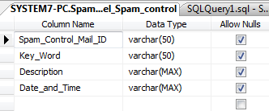
Admin User:
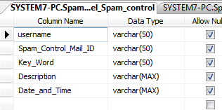

User:
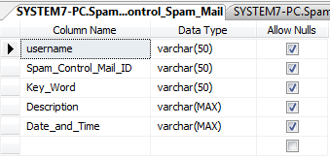
Mail Inbox:
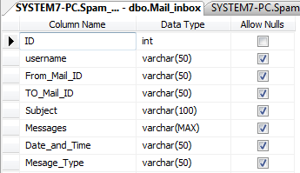
Register:
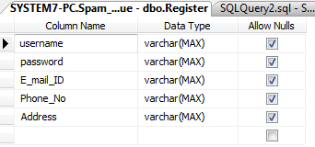

Sent Mail:
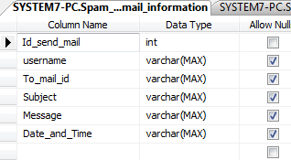
4.3 INPUT DESIGN
In the input design, user-oriented inputs are converted into a computer based system format. It also includes determining the record media, method of input, speed of capture and entry on to the screen. Online data entry accepts commands and data through a keyboard. The major approach to input design is the menu and the prompt design. In each alternative, the user’s options are predefined. The data flow diagram indicates logical data flow, data stores, source and destination. Input data are collected and organized into a group of similar data. Once identified input media are selected for processing.

In this software, importance is given to develop Graphical User Interface (GUI), which is an important factor in developing efficient and user-friendly software. For inputting user data, attractive forms are designed. User can also select desired options from the menu, which provides all possible facilities.

Also, the important input format is designed in such a way that accidental errors are avoided. The user has to input only just the minimum data required, which also helps in avoiding the errors that the users may make. Accurate designing of the input format is very important in developing efficient software. The goal or input design is to make entry as easy, logical and free from errors.

INPUT | FORMAT
Netwuser name | Alpha numeric
Password | Alpha numeric
Email ID | Alpha numeric
Phone NO | Alpha numeric
Address | Alpha numeric

4.4 SFD/DFD
A data flow diagram is graphical tool used to describe and analyze movement of data through a system. These are the central tool and the basis from which the other components are developed. The transformation of data from input to output, through processed, may be described logically and independently of physical components associated with the system. These are known as the logical data flow diagrams. The physical data flow diagrams show the actual implements and movement of data between people, departments and workstations. A full description of a system actually consists of a set of data flow diagrams. Using two familiar notations Yourdon, Gane and Sarson notation develops the data flow diagrams. Each component in a DFD is labeled with a descriptive name. Process is further identified with a number that will be used for identification purpose. The development of DFD’S is done in several levels. Each process in lower level diagrams can be broken down into a more detailed DFD in the next level. The lop-level diagram is often called context diagram. It consists a single process bit, which plays vital role in studying the current system. The process in the context level diagram is exploded into other process at the first level DFD.
The idea behind the explosion of a process into more process is that understanding at one level of detail is exploded into greater detail at the next level. This is done until further explosion is necessary and an adequate amount of detail is described for analyst to understand the process.
Larry Constantine first developed the DFD as a way of expressing system requirements in a graphical from, this lead to the modular design.
A DFD is also known as a “bubble Chart” has the purpose of clarifying system requirements and identifying major transformations that will become programs in system design. So it is the starting point of the design to the lowest level of detail. A DFD consists of a series of bubbles joined by data flows in the system.
DFD symbols:
In the DFD, there are four symbols
- A square defines a source(originator) or destination of system data
- An arrow identifies data flow. It is the pipeline through which the information flows
- A circle or a bubble represents a process that transforms incoming data flow into outgoing data flows.
- An open rectangle is a data store, data at rest or a temporary repository of data

Process that transforms data flow.

Source or Destination of data
Data flow

Data Store

Constructing a DFD:
Several rules of thumb are used in drawing DFD’S:
- Process should be named and numbered for an easy reference. Each name should be representative of the process.
- The direction of flow is from top to bottom and from left to right. Data traditionally flow from source to the destination although they may flow back to the source. One way to indicate this is to draw long flow line back to a source. An alternative way is to repeat the source symbol as a destination. Since it is used more than once in the DFD it is marked with a short diagonal.
- When a process is exploded into lower level details, they are numbered.
- The names of data stores and destinations are written in capital letters. Process and dataflow names have the first letter of each work capitalized.
A DFD typically shows the minimum contents of data store. Each data store should contain all the data elements that flow in and out.
Questionnaires should contain all the data elements that flow in and out. Missing interfaces redundancies and like is then accounted for often through interviews.

Salient Features Of DFD’s
- The DFD shows flow of data, not of control loops and decision are controlled considerations do not appear on a DFD.
- The DFD does not indicate the time factor involved in any process whether the dataflow take place daily, weekly, monthly or yearly.
- The sequence of events is not brought out on the DFD.

Types of Data Flow Diagrams
- Current Physical
- Current Logical
- New Logical
- New Physical

CURRENT PHYSICAL:
In Current Physical DFD process label include the name of people or their positions or the names of computer systems that might provide some of the overall system-processing label includes an identification of the technology used to process the data. Similarly data flows and data stores are often labels with the names of the actual physical media on which data are stored such as file folders, computer files, business forms or computer tapes.
CURRENT LOGICAL:
The physical aspects at the system are removed as much as possible so that the current system is reduced to its essence to the data and the processors that transforms them regardless of actual physical form.
NEW LOGICAL:
This is exactly like a current logical model if the user were completely happy with the user were completely happy with the functionality of the current system but had problems with how it was implemented typically through the new logical model will differ from current logical model while having additional functions, absolute function removal and inefficient flows recognized.
NEW PHYSICAL:
The new physical represents only the physical implementation of the new system.

RULES GOVERNING THE DFD’S

PROCESS
- No process can have only outputs.
- No process can have only inputs. If an object has only inputs than it must be a sink.
- A process has a verb phrase label.

DATA STORE
- Data cannot move directly from one data store to another data store, a process must move data.
- Data cannot move directly from an outside source to a data store, a process, which receives, must move data from the source and place the data into data store
- A data store has a noun phrase label.

SOURCE OR SINK
The origin and /or destination of data.
- Data cannot move direly from a source to sink it must be moved by a process
- A source and /or sink has a noun phrase land

DATA FLOW
- A Data Flow has only one direction of flow between symbols. It may flow in both directions between a process and a data store to show a read before an update. The later is usually indicated however by two separate arrows since these happen at different type.
- A join in DFD means that exactly the same data comes from any of two or more different processes data store or sink to a common location.
- A data flow cannot go directly back to the same process it leads. There must be at least one other process that handles the data flow produce some other data flow returns the original data into the beginning process.
- A Data flow to a data store means update (delete or change).
- A data Flow from a data store means retrieve or use.
A data flow has a noun phrase label more than one data flow noun phrase can appear on a single arrow as long as all of the flows on the same arrow move together as one package
Dataflow Diagram
Level 0

Level 1:

Level 2:

Admin

Level 4

UML DIAGRAMS
Class diagram

Use Case Diagram

Sequence diagram
Activity diagram

ER Diagram:
username
password
UID
gender
User type
email
mobile

Mail id

User
Subject
Body
Mail
Upload File
Header
Mail size
username
password
Admin
Mail content

Spam Check

Spam ID
Username
Spam
ID
Date

CHAPTER 05 : SYSTEM DESCRIPTION :
MODULES
- Attack scenario and model of the adversary
- A model of the data distribution
- Training and testing set generation
- Performance evaluation

MODULE DESCRIPTION
Attack Scenario and Model of the Adversary
Although the definition of attack scenarios is ultimately an application-specific issue, it is possible to give general guidelines that can help the designer of a pattern recognition system. Here we propose to specify the attack scenario in terms of a conceptual model of the adversary that encompasses, unifies, and extends different ideas from previous work. Our model is based on the assumption that the adversary acts rationally to attain a given goal, according to her knowledge of the classifier, and her capability of manipulating data. This allows one to derive
the corresponding optimal attack strategy.

Adversary’s goal: It is formulated as the optimization of an objective function. We propose to define this function based on the desired security violation(integrity, availability, or privacy), and on the attack specificity (from targeted to indiscriminate), according to the taxonomy. For instance, the goal of an indiscriminate integrity violation may be to maximize the fraction of misclassified malicious samples; the goal of a targeted privacy violation may be to obtain some specific, confidential information from the classifier (e.g., the biometric trait of a given user enrolled in a biometric system) by exploiting the class labels assigned to some “query” samples, while minimizing the number of query samples that the adversary
has to issue to violate privacy.

CHAPTER 6: TESTING AND IMPLEMENTATION :
The goal of testing is to improve the program’s quality. Quality is assured primarily through some form of software testing. The history of testing goes back to the beginning of the computing field. Testing is done at two Levels of Testing of individual modules and testing the entire system. During the system testing, the system is used experimentally to ensure that the software will run according to the specifications and in the way the user expects. Testing is very tedious and time consuming. Each test case is designed with the intent of finding errors in the way the system will process it.

LEVELS OF TESTING
The software underwent the following tests by the system analyst.
WHITE BOX TESTING
By using this technique it was tested that all the individual logical paths were executed at least once. All the logical decisions were tested on both their true and false sides. All the loops were tested with data in between the ranges and especially at the boundary values.

BLACK BOX TESTING
By the use of this technique, the missing functions were identified and placed in their positions. The errors in the interfaces were identified and corrected. This technique was also used to identify the initialization and termination errors and correct them.

UNIT TESTING
It is the verification of a single module usually in the isolated environment. The System Analyst tests each and every module individually by giving a set of known input data and verifying for the required output data. The System Analyst tested the software Top Down model starting from the top of the model. The units in a system are the modules and routines that are assembled to perform a specific function. The modules should be tested for correctness of login applied and should detect errors in coding. This is the verification of the system to its initial objective. This is a verification process when it is done in a simulated environment and it is a validation process when it is done in a line environment.
INTEGRATION TESTING
The purpose of unit testing is to determine that each independent module is correctly implemented. This gives little chance to determine that the interface between modules is also correct and for this reason integration testing must be performed. One specific target of integration testing is the interface. Whether parameters match on both sides as to type, permissible ranges, meaning and utilization. Module testing assures us that the detailed design was correctly implemented; now it is necessary to verity that the architectural design specifications were met. Chosen portions of the structure tree of the software are put together. Each sub tree should have some logical reason for being tested. It may be a particularly difficult or tricky part of the code; or it may be essential to the function of the rest of the product. As the testing progresses, we find ourselves putting together larger and longer parts of the tree, until the entire product has been integrated.

VALIDATION TESTING

The main aim of this testing is to verify that the software system does what it was designed for the system was tested to ensure that the purpose of automating the system “Machine Order” .Alpha testing was carried out to ensure the validity of the system.

OUTPUT TESTING

Asking the users about the format required by them tests the outputs generated by the system under consideration .The output format on the screen is found to be correct as the format was designed in the system design. Output testing was done and it did not result in any change or correction in the system.

USER ACCEPTANCE TESTING

The system under consideration is tested for user acceptance by constantly keeping in touch with prospective system users at time of developing and making changes whenever required. The following points are considered.

Input screen design

Output screen design

Online message to guide the user

Menu driven system

Format of adhoc queries and reports

PERFORMANCE TESTING

Performance is taken as the last part of implementation. Performance is perceived as response time for user queries, report generation and process related activities.
Test Cases:
We are following Ad-Hoc testing.
Test Case Id | Test Case Name | Test Case Description | Expected Result | Actual Result | Test Result  (P/F) | Test Severity | Test Priority
001 | login | Login stage | To verify login name, password, transaction code | Login successful | P | - | -
002 | Registration | Enter the require details and login | To enter name, gender, contact, address , email id , occupation, password | Registration successful | P | - | -
003 | Certification creation | Certificate creation | To enter the details of transaction ID, name, contact no, certification validity, amount, bank, upload biometrics. | Certificate creation  successful | P | - | -
004 | Download certificate | To browse & download certificate | To verify username, transaction code, biometrics | Download certificate | P | - | -
005 | Upload file and encryption file | File outsourcing | To enter certificate no, upload file, outsourching server and encrypted data | Encrypted file | p | - | -
006 | Server file list | To select the file & download | Server file list Show files and download | Download  File successful | P | - | -
007 | Save file | Encrypted file | Save the file | Encrypted File saved | P | - | -

Category 1: System Initialization & Setup
Test Case ID: TC-INIT-01
Test Case Name: Classifier Model Initialization
Description: Verify that the pattern classifier system initializes correctly with all models loaded.
Preconditions: Classifier software installed; dataset available.
Test Steps:
- Start the classifier application.
- Load pre-trained models.
- Verify models are ready for input.
Expected Result: All models loaded successfully; system ready for evaluation.
Actual Result: —
Status: Pass/Fail
Test Case ID: TC-INIT-02
Test Case Name: Dataset Integrity Check
Description: Verify that the input dataset is accessible and not corrupted.
Preconditions: Dataset stored in system.
Test Steps:
- Load dataset into classifier.
- Check for missing or corrupted entries.
Expected Result: Dataset loaded completely without errors.
Actual Result: —
Status: Pass/Fail

Category 2: Normal Classification Performance
Test Case ID: TC-NORM-01
Test Case Name: Standard Classification Accuracy
Description: Verify classifier performance under normal, attack-free conditions.
Preconditions: Clean dataset available; classifier initialized.
Test Steps:
- Input test dataset.
- Record classification results.
- Measure accuracy, precision, and recall.
Expected Result: Classifier achieves expected accuracy based on baseline performance.
Actual Result: —
Status: Pass/Fail
Test Case ID: TC-NORM-02
Test Case Name: Performance Under High Load
Description: Verify classifier works efficiently with large dataset.
Preconditions: Dataset with ≥10,000 samples.
Test Steps:
- Submit dataset to classifier.
- Measure time taken per classification.
Expected Result: Classification completes within acceptable time limits without errors.
Actual Result: —
Status: Pass/Fail

Category 3: Attack Simulation & Robustness
Test Case ID: TC-ATTACK-01
Test Case Name: Adversarial Input Attack
Description: Verify classifier behavior when adversarial samples are provided.
Preconditions: Adversarial examples generated using perturbation methods.
Test Steps:
- Feed adversarial inputs to classifier.
- Observe output labels and confidence scores.
Expected Result: Classifier performance degrades according to expected robustness; misclassifications logged.
Actual Result: —
Status: Pass/Fail
Test Case ID: TC-ATTACK-02
Test Case Name: Poisoning Attack on Training Data
Description: Verify classifier resilience when training data is poisoned.
Preconditions: Training dataset modified with malicious samples.
Test Steps:
- Retrain classifier with poisoned dataset.
- Evaluate classification performance on clean test set.
Expected Result: Classifier exhibits performance drop; detection mechanisms trigger alerts if implemented.
Actual Result: —
Status: Pass/Fail
Test Case ID: TC-ATTACK-03
Test Case Name: Evasion Attack at Test Time
Description: Verify classifier behavior when attacker modifies inputs at testing stage.
Preconditions: Test dataset accessible; evasion attack vectors prepared.
Test Steps:
- Submit modified test samples.
- Monitor prediction outputs and misclassification rate.
Expected Result: System logs unusual confidence distributions; misclassification increases.
Actual Result: —
Status: Pass/Fail

Category 4: Security & Logging
Test Case ID: TC-SEC-01
Test Case Name: Logging of Suspicious Classification Events
Description: Verify all adversarial or anomalous classification events are logged.
Preconditions: Logging enabled in classifier.
Test Steps:
- Run attack simulations.
- Check system logs.
Expected Result: All anomalous or suspicious inputs recorded with timestamp, input ID, and classification result.
Actual Result: —
Status: Pass/Fail
Test Case ID: TC-SEC-02
Test Case Name: Alert Generation for High-Risk Inputs
Description: Verify alerts triggered when classifier detects abnormal confidence or misclassification.
Preconditions: Alert mechanism configured.
Test Steps:
- Run dataset with adversarial inputs.
- Observe alerts in dashboard or logs.
Expected Result: Alerts generated only for high-risk or suspicious events.
Actual Result: —
Status: Pass/Fail

Category 5: Performance & Reliability Under Attack
Test Case ID: TC-PERF-01
Test Case Name: Classification Latency Under Adversarial Load
Description: Measure time taken for classification under attack scenarios.
Preconditions: Classifier and attack vectors ready.
Test Steps:
- Submit adversarial test dataset.
- Measure classification latency.
Expected Result: System maintains acceptable latency (< 2x normal load).
Actual Result: —
Status: Pass/Fail
Test Case ID: TC-PERF-02
Test Case Name: Resource Utilization Monitoring
Description: Verify CPU/memory usage during attack simulation.
Preconditions: Monitoring tools active.
Test Steps:
- Run attack scenarios on classifier.
- Record CPU and memory utilization.
Expected Result: Resource consumption remains within safe thresholds.
Actual Result: —
Status: Pass/Fail
Test Case ID: TC-PERF-03
Test Case Name: Recovery After Attack Simulation
Description: Verify classifier returns to baseline performance after attack stops.
Preconditions: Attack scenarios completed.
Test Steps:
- Run clean test dataset after attacks.
- Measure accuracy and performance.
Expected Result: Classifier recovers baseline performance metrics.
Actual Result: —
Status: Pass/Fail
CHAPTER 07: CONCLUSION AND FUTURESCOPE
In this paper we focused on empirical security evaluation of pattern classifiers that have to be deployed in adversarial environments, and proposed how to revise the classical performance evaluation design step, which is not suitable for this purpose. Our main contribution is a framework for empirical security evaluation that formalizes and generalizes ideas from previous work, and can be applied to different classifiers, learning algorithms, and classification tasks. It is grounded on a formal model of the adversary, and on a model of data distribution that can represent all the attacks considered in previous work; provides a systematic method for the generation of training and testing sets that enables security evaluation; and can accommodate application-specific techniques for attack simulation. This is a clear advancement with respect to previous work, since without a general framework most of the proposed techniques (often tailored to a given classifier model, attack, and application) could not be directly applied to other problems.

An intrinsic limitation of our work is that security evaluation is carried out empirically, and it is thus data dependent; on the other hand, model-driven analyses require a full analytical model of the problem and of the adversary’s behavior, that may be very difficult to develop for real-world applications. Another intrinsic limitation is due to fact that our method is not application-specific, and, therefore, provides only high level guidelines for simulating attacks. Indeed, detailed guidelines require one to take into account application specific constraints and adversary models. Our future work will be devoted to develop techniques for simulating attacks for different applications. Although the design of secure classifiers is a distinct problem than security evaluation, our framework could be also exploited to this end. For instance, simulated attack samples can be included into the training data to improve security of discriminative classifiers (e.g., SVMs),while the proposed data model can be exploited to design more secure generative classifiers. We obtained encouraging preliminary results on this topic

CHAPTER 8: FORMS AND REPORTS :

Admin:
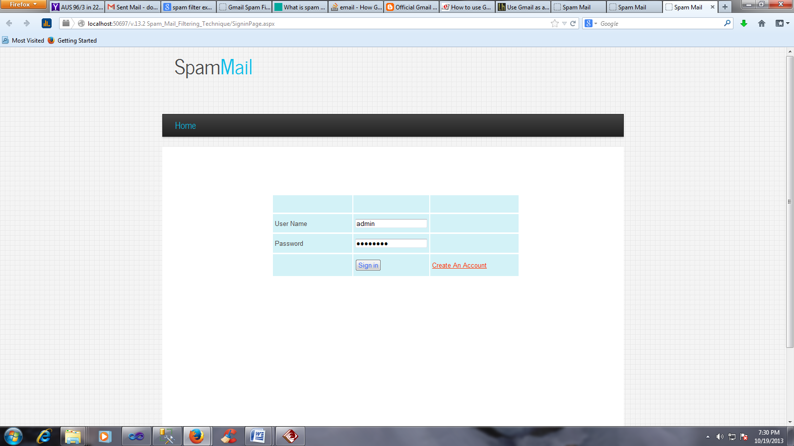

Admin user:
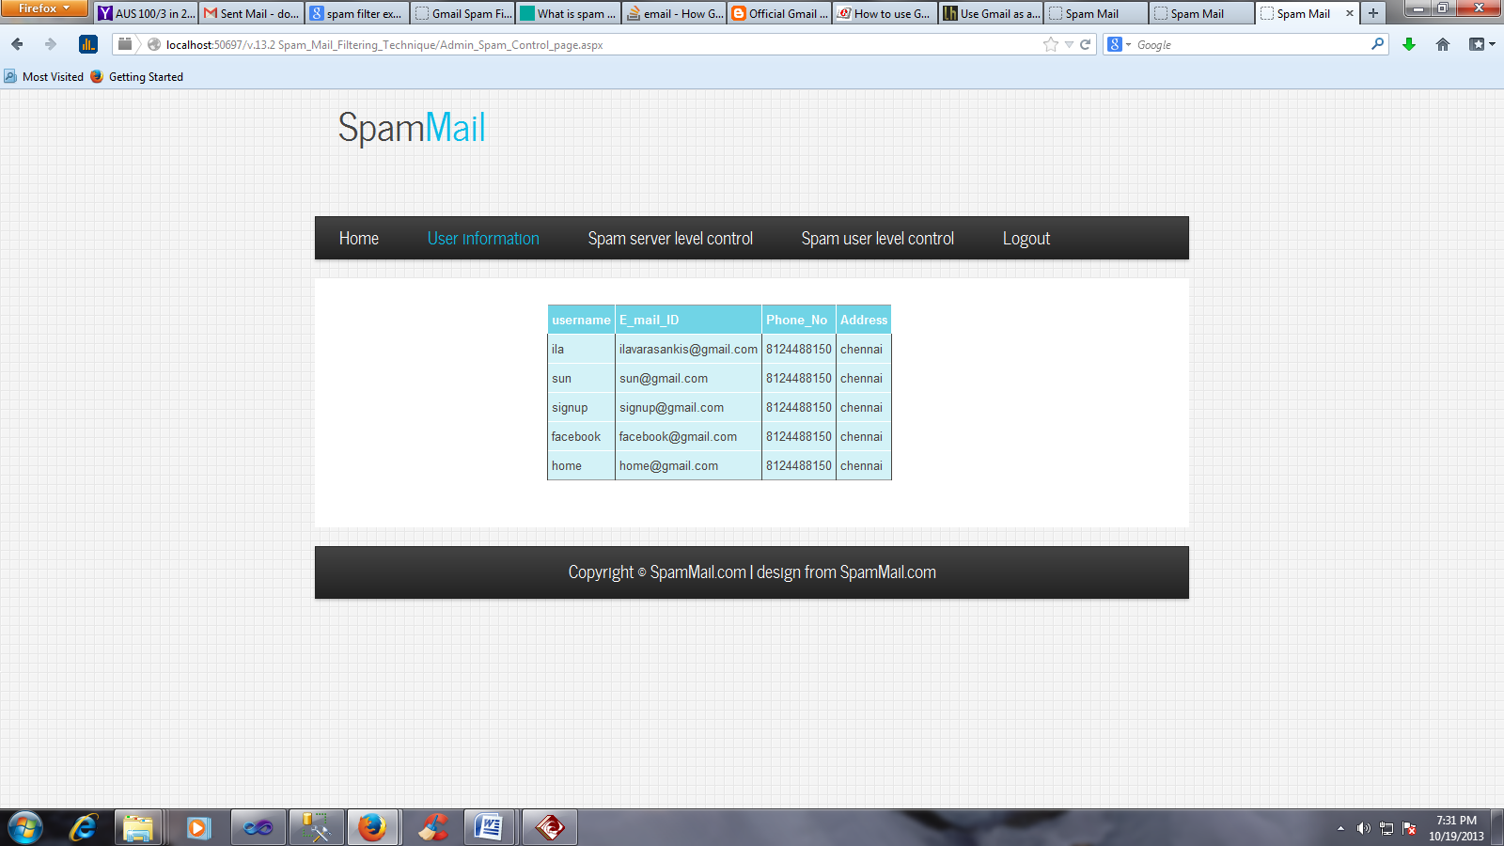

Spam server level control:
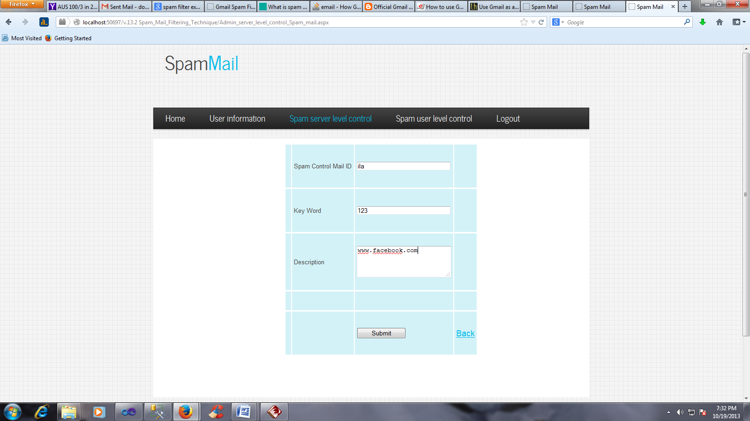

Spam user level control:
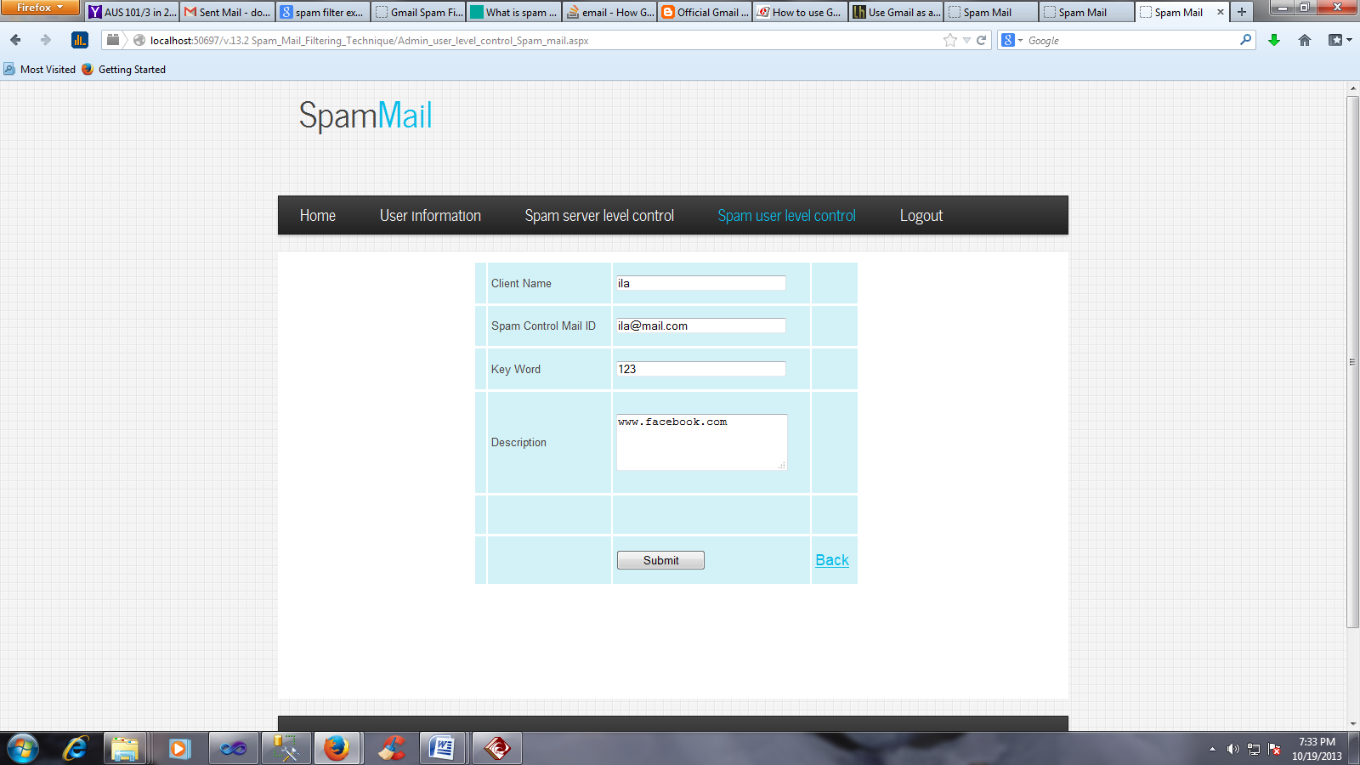

User inbox:
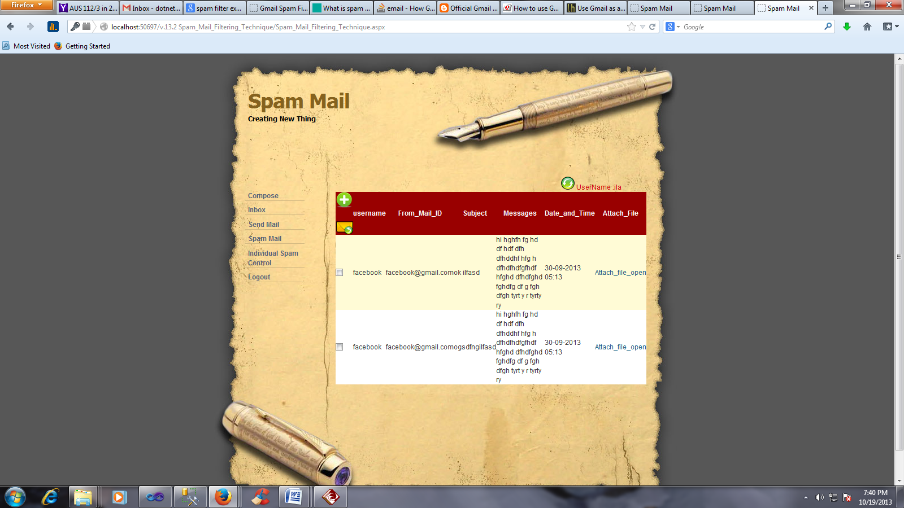

User composes:
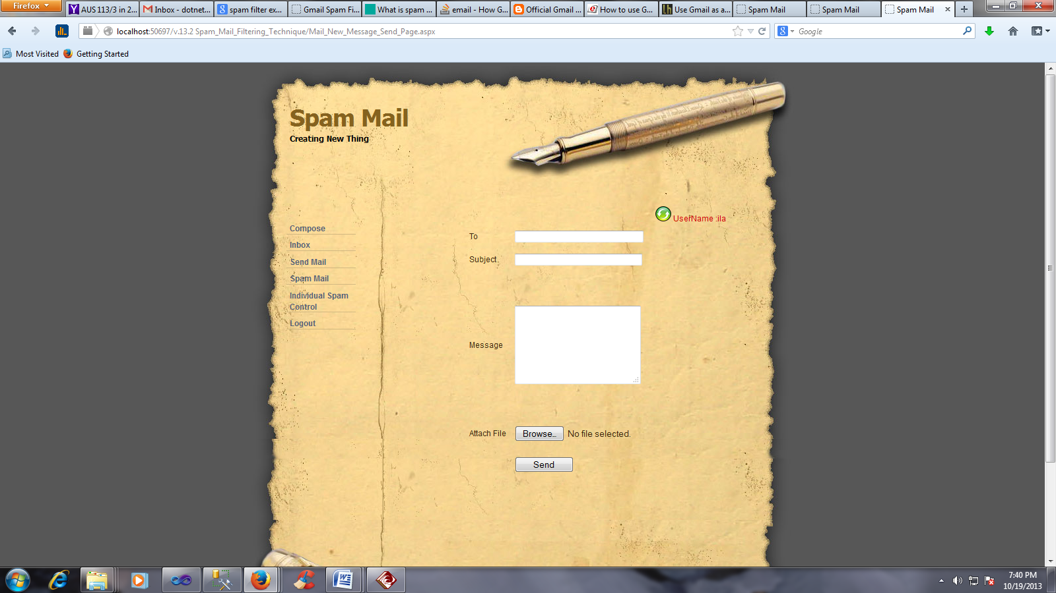

User sent item:
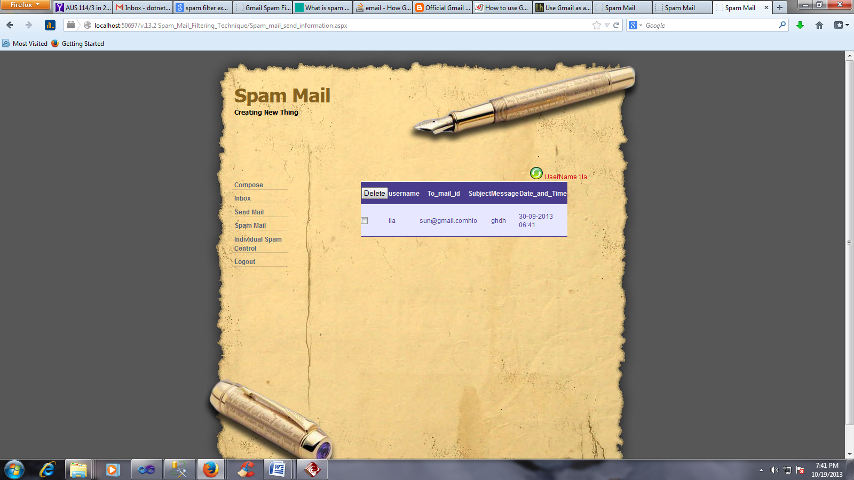

Spam control:
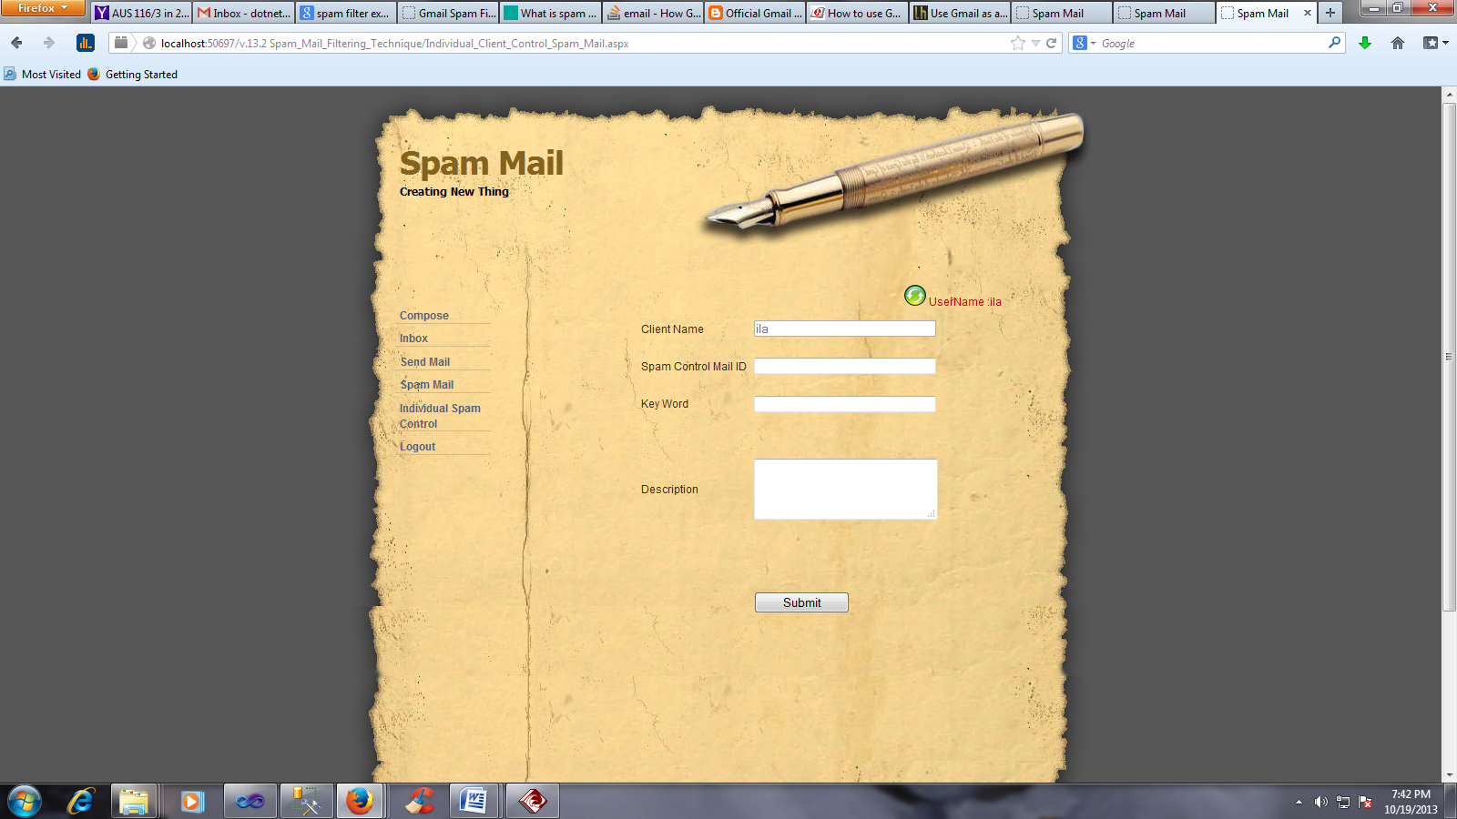

User Register:
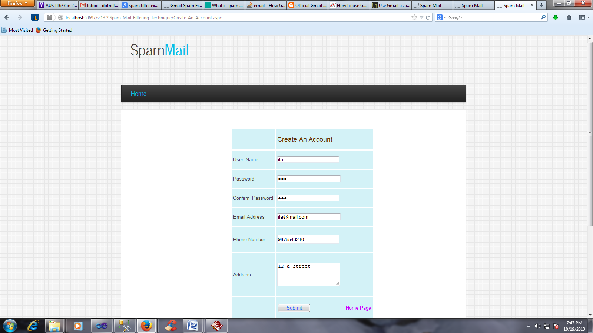
CHAPTER 9: BIBILOGRAPHY :
[1] R. N. Rodrigues, L. L. Ling, and V. Govindaraju, “Robustness ofmultimodal biometric fusion methods against spoof attacks,” J.Vis. Lang. Comput., vol. 20, no. 3, pp. 169–179, 2009.

[2] P. Johnson, B. Tan, and S. Schuckers, “Multimodal fusion vulnerabilityto non-zero effort (spoof) imposters,” in IEEE Int’l Workshopon Inf. Forensics and Security, 2010, pp. 1–5.

[3] P. Fogla, M. Sharif, R. Perdisci, O. Kolesnikov, and W. Lee,“Polymorphic blending attacks,” in Proc. 15th Conf. on USENIXSecurity Symp. CA, USA: USENIX Association, 2006.

[4] G. L. Wittel and S. F. Wu, “On attacking statistical spam filters,”in 1st Conf. on Email and Anti-Spam, CA, USA, 2004.

[5] D. Lowd and C. Meek, “Good word attacks on statistical spamfilters,” in 2nd Conf. on Email and Anti-Spam, CA, USA, 2005.

[6] A. Kolcz and C. H. Teo, “Feature weighting for improved classifierrobustness,” in 6th Conf. on Email and Anti-Spam, CA, USA, 2009.

[7] D. B. Skillicorn, “Adversarial knowledge discovery,” IEEE Intell.Syst., vol. 24, pp. 54–61, 2009.

[8] D. Fetterly, “Adversarial information retrieval: The manipulationof web content,” ACM Computing Reviews, 2007.

[9] R. O. Duda, P. E. Hart, and D. G. Stork, Pattern Classification.Wiley-Interscience Publication, 2000.
[10] N. Dalvi, P. Domingos, Mausam, S. Sanghai, and D. Verma,“Adversarial classification,” in 10th ACM SIGKDD Int’l Conf. onKnowl. Discovery and Data Mining, WA, USA, 2004, pp. 99–108.

[11] M. Barreno, B. Nelson, R. Sears, A. D. Joseph, and J. D. Tygar,“Can machine learning be secure?” in Proc. Symp. Inf., Computerand Commun. Sec. (ASIACCS). NY, USA: ACM, 2006, pp. 16–25.

[12] A. A. C´ardenas and J. S. Baras, “Evaluation of classifiers: Practicalconsiderations for security applications,” in AAAI Workshop onEvaluation Methods for Machine Learning, MA, USA, 2006.

[13] P. Laskov and R. Lippmann, “Machine learning in adversarialenvironments,” Machine Learning, vol. 81, pp. 115–119, 2010.

[14] L. Huang, A. D. Joseph, B. Nelson, B. Rubinstein, and J. D. Tygar,“Adversarial machine learning,” in 4th ACM Workshop on ArtificialIntelligence and Security, IL, USA, 2011, pp. 43–57.

[15] M. Barreno, B. Nelson, A. Joseph, and J. Tygar, “The security ofmachine learning,” Machine Learning, vol. 81, pp. 121–148, 2010.

SAMPLE CODE
Admin server Level coding:

using System;
usingSystem.Collections.Generic;
usingSystem.Linq;
usingSystem.Web;
usingSystem.Web.UI;
usingSystem.Web.UI.WebControls;
usingSystem.Data;
usingSystem.Data.SqlClient;
usingSystem.Configuration;

publicpartialclassAdmin_server_level_control_Spam_mail : System.Web.UI.Page
{
SqlConnection con = newSqlConnection(ConfigurationManager.ConnectionStrings["sql_con"].ConnectionString);
publicstaticstring admin_username1, Date_and_Time;
protectedvoidPage_Load(object sender, EventArgs e)
{
System.Web.UI.HtmlControls.HtmlGenericControlliHome = (System.Web.UI.HtmlControls.HtmlGenericControl)this.Master.FindControl("liHome");
liHome.Attributes.Add("class", "");
System.Web.UI.HtmlControls.HtmlGenericControlliUserinformation = (System.Web.UI.HtmlControls.HtmlGenericControl)this.Master.FindControl("liUserinformation");
liUserinformation.Attributes.Add("class", "");
System.Web.UI.HtmlControls.HtmlGenericControlliSpamserverlevelcontrol = (System.Web.UI.HtmlControls.HtmlGenericControl)this.Master.FindControl("liSpamserverlevelcontrol");
liSpamserverlevelcontrol.Attributes.Add("class", "selected");
System.Web.UI.HtmlControls.HtmlGenericControlliSpamuserlevelcontrol = (System.Web.UI.HtmlControls.HtmlGenericControl)this.Master.FindControl("liSpamuserlevelcontrol");
liSpamuserlevelcontrol.Attributes.Add("class", "");

if (Session["admin_username"] != null)
{
admin_username1 = Session["admin_username"].ToString();
}
else
{
Response.Redirect("SigninPage.aspx");
}

}
protectedvoidBut_Submit_Click(object sender, EventArgs e)
{
if (TextBox2.Text == "" || TextBox3.Text == "" || TextBox4.Text == "")
{
ClientScript.RegisterStartupScript(typeof(Page), "alert", "<script language=JavaScript>alert('Enter all values'); </script>");//individual client

}
else
{
stringdate_value = DateTime.Now.ToString("dd-MM-yyyy");
stringtime_value = DateTime.Now.ToString("hh:mm");

Date_and_Time = date_value + " " + time_value;

if (con.State == ConnectionState.Closed)
con.Open();
SqlCommandcmd = newSqlCommand("insert into Admin_server_level_Spam_control(Spam_Control_Mail_ID,Key_Word,Description,Date_and_Time)values('" + TextBox2.Text + "','" + TextBox3.Text + "','" + TextBox4.Text + "','" + Date_and_Time + "')", con);
cmd.ExecuteNonQuery();
if (con.State == ConnectionState.Open)
con.Close();
ClientScript.RegisterStartupScript(typeof(Page), "alert", "<script language=JavaScript>alert('Submit Sucessfully'); </script>");
}
}
protectedvoidLinkBut_Back_Click(object sender, EventArgs e)
{
Response.Redirect("Admin_Spam_Control_page.aspx");
}
}

Spam Filtering:
using System;
usingSystem.Collections.Generic;
usingSystem.Linq;
usingSystem.Web;
usingSystem.Web.UI;
usingSystem.Web.UI.WebControls;
usingSystem.Data;
usingSystem.Data.SqlClient;
usingSystem.Configuration;
using System.IO;

publicpartialclassSpam_Filtering_Mail_Box : System.Web.UI.Page
{
SqlConnection con = newSqlConnection(ConfigurationManager.ConnectionStrings["sql_con"].ConnectionString);
publicstaticstring username, Mesage_Type, E_mail_ID, Date_and_Time, Attach_file_path;
protectedvoidPage_Load(object sender, EventArgs e)
{
if (Session["user_name"] != null)
{
username = Session["user_name"].ToString();
if (con.State == ConnectionState.Closed)
con.Open();
User_mail_id();

if (!IsPostBack)
{
Loadvalue();
}
//if (con.State == ConnectionState.Open)
// con.Close();

////string
////SqlDataAdaptersda = new SqlDataAdapter("select username,E_mail_ID,Phone_No,Address from Register", con);
////SqlDataAdaptersda = new SqlDataAdapter("select username,From_Mail_ID,Subject,Messages,Date_and_Time from Mail_inbox Where TO_Mail_ID='" + E_mail_ID + "' and Mesage_Type='" + "spam_mail" + "'", con);
////DataSet ds = new DataSet();
////sda.Fill(ds, "Mail_inbox");
////GridView1.DataSource = ds.Tables[0].DefaultView;
////GridView1.DataBind();

//if (con.State == ConnectionState.Open)
// con.Close();

}
else
{
Response.Redirect("SigninPage.aspx");
}
}
publicvoidLoadvalue()
{
if (con.State == ConnectionState.Closed)
con.Open();

SqlDataAdaptersda = newSqlDataAdapter("select ID,username,From_Mail_ID,Subject,Messages,Date_and_Time from Mail_inbox Where TO_Mail_ID='" + E_mail_ID + "' and Mesage_Type='" + "spam_mail" + "'", con);
DataSet ds = newDataSet();
sda.Fill(ds, "Mail_inbox");
GridView1.DataSource = ds.Tables[0].DefaultView;
GridView1.DataBind();
if (con.State == ConnectionState.Open)
con.Close();
}
publicvoidUser_mail_id()
{
if (con.State == ConnectionState.Closed)
con.Open();
SqlCommandcmd_select = newSqlCommand("Select username,E_mail_ID From Register Where username='" + username + "'", con);
SqlDataReaderdr = cmd_select.ExecuteReader();

if (dr.Read())
{
E_mail_ID = dr["E_mail_ID"].ToString();
}
if (con.State == ConnectionState.Open)
con.Close();
}
//protected void But_delete_Click(object sender, EventArgs e)
//{
// try
// {
// if (con.State == ConnectionState.Closed)
// con.Open();
// for (inti = 0; i< GridView1.Rows.Count; i++)
// {
// CheckBoxckbItem = (CheckBox)GridView1.Rows[i].FindControl("chkItem");
// Label lblID = (Label)GridView1.Rows[i].FindControl("lblID");
// if (ckbItem.Checked == true)
// {
// SqlCommandcmd_Delete = new SqlCommand("Delete from Mail_inbox Where ID='" + lblID.Text + "'", con);
// cmd_Delete.ExecuteNonQuery();
// }
// else
// {

// }
// }
// if (con.State == ConnectionState.Open)
// con.Close();
// }
// catch (Exception ex)
// {

// }
// finally
// {
// Loadvalue();
// }
//}
publicvoidfile_dow()
{
stringfilePath = Attach_file_path;

FileInfo file = newFileInfo(filePath);
string fileName111 = Path.GetFileName(file.FullName);
if (file.Exists)
{
Response.ContentType = ReturnExtension(file.Extension.ToLower());
Response.AddHeader("Content-Disposition", "attachment;filename=\"" + fileName111 + "\"");
Response.TransmitFile(filePath);
Response.End();
// ClientScript.RegisterStartupScript(typeof(Page), "alert", "<script language=JavaScript>alert('Downloads Sucessfully'); </script>");

}
}
privatestringReturnExtension(stringfileExtension)
{
switch (fileExtension)
{
case".htm":
case".html":
case".log":
return"text/HTML";
case".txt":
return"text/plain";
case".doc":
return"application/ms-word";
case".docx":
return"application/vnd.msword.document.12";
case".tiff":
case".tif":
return"image/tiff";
case".asf":
return"video/x-ms-asf";
case".avi":
return"video/avi";
case".zip":
return"application/zip";
case".xls":
case".csv":
return"application/vnd.ms-excel";
case".gif":
return"image/gif";
case".jpg":
case"jpeg":
return"image/jpeg";
case".bmp":
return"image/bmp";
case".wav":
return"audio/wav";
case".mp3":
return"audio/mpeg3";
case".mpg":
case"mpeg":
return"video/mpeg";
case".rtf":
return"application/rtf";
case".asp":
return"text/asp";
case".pdf":
return"application/pdf";
case".fdf":
return"application/vnd.fdf";
case".ppt":
return"application/mspowerpoint";
case".dwg":
return"image/vnd.dwg";
case".msg":
return"application/msoutlook";
case".xml":
case".sdxl":
return"application/xml";
case".xdp":
return"application/vnd.adobe.xdp+xml";
default:
return"application/octet-stream";
}
}
protectedvoid GridView1_RowCommand(object sender, GridViewCommandEventArgs e)
{
if (e.CommandName == "Attach")
{
stringstr = e.CommandArgument.ToString();
if (con.State == ConnectionState.Closed)
con.Open();

SqlCommandcmd_select_file = newSqlCommand("Select Attach_file From Mail_inbox Where ID='" + str + "'", con);
SqlDataReaderdr_file = cmd_select_file.ExecuteReader();
if (dr_file.HasRows)
{

if (dr_file.Read())
{

Attach_file_path = dr_file["Attach_file"].ToString();
if (Attach_file_path != "")
{
file_dow();
}
}
}
if (con.State == ConnectionState.Open)
con.Close();
}
}
protectedvoidImgb_delete_Click(object sender, ImageClickEventArgs e)
{
try
{
if (con.State == ConnectionState.Closed)
con.Open();
for (inti = 0; i< GridView1.Rows.Count; i++)
{
CheckBoxckbItem = (CheckBox)GridView1.Rows[i].FindControl("chkItem");
LabellblID = (Label)GridView1.Rows[i].FindControl("lblID");
if (ckbItem.Checked == true)
{
SqlCommandcmd_Delete = newSqlCommand("Delete from Mail_inbox Where ID='" + lblID.Text + "'", con);
cmd_Delete.ExecuteNonQuery();
}
else
{

}
}
if (con.State == ConnectionState.Open)
con.Close();
}
catch (Exception ex)
{
}
finally
{
Loadvalue();
}
}
protectedvoidImgb_move_Click(object sender, ImageClickEventArgs e)
{
try
{
if (con.State == ConnectionState.Closed)
con.Open();
for (inti = 0; i< GridView1.Rows.Count; i++)
{
CheckBoxckbItem = (CheckBox)GridView1.Rows[i].FindControl("chkItem");
LabellblID = (Label)GridView1.Rows[i].FindControl("lblID");
if (ckbItem.Checked == true)
{
string Mesage_Type1 = "inbox_mail";

SqlCommandcmd_update = newSqlCommand("update Mail_inbox set Mesage_Type='" + Mesage_Type1 + "' Where ID='" + lblID.Text + "' ", con);
cmd_update.ExecuteNonQuery();

}
else
{

}
}
if (con.State == ConnectionState.Open)
con.Close();
}
catch (Exception ex)
{

}
finally
{
Loadvalue();
}
}
protectedvoidImgb_reply_Click(object sender, ImageClickEventArgs e)
{
}
}

